Functional Specification

Search

Table of Contents

1 PERMISSION CONTROL 2

2 PAGE LAYOUT 2

2.1 Blank Search 2

2.2 Search Result List 3

2.3 No Result Search 4

# PERMISSION CONTROL

* All login users can use the search function, click the search icon on the top right corner of each page will open the search panel

# PAGE LAYOUT

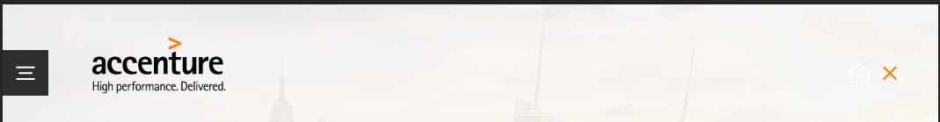

* There are burger menu, Accenture logo and one close(x) icon on the header of the search panel
* Click burger menu will open the menu
* Click Accenture Logo will go to the homepage
* Click close(x) icon will close the search panel

## Blank Search

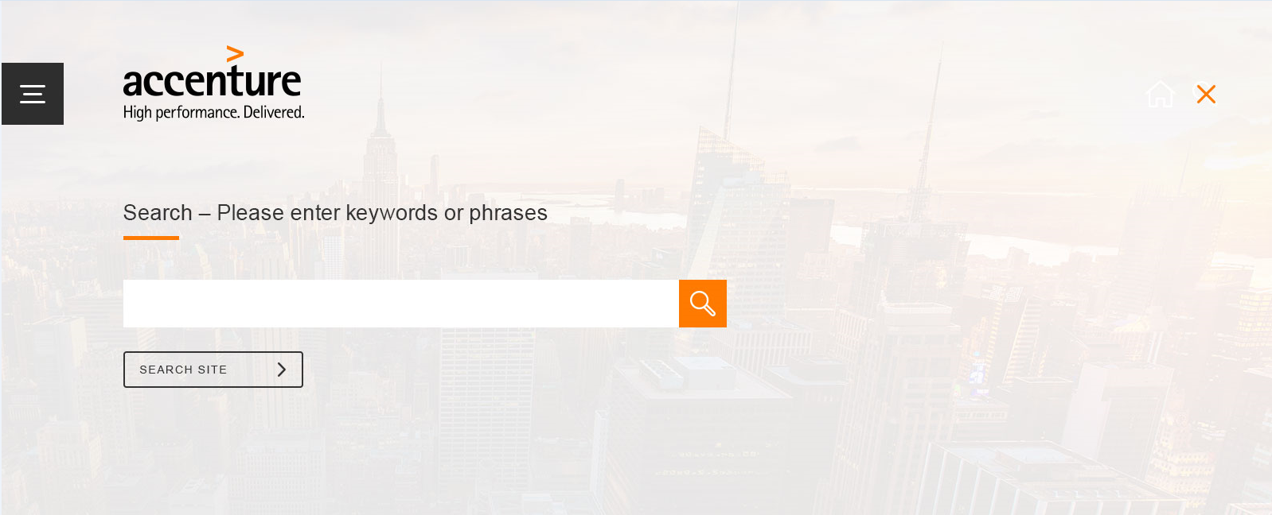

* Title texts above the search box is “Search – Please enter keywords or phrases”
* There is a search area dropdown list which has below options:  
  SEATCH SITE This will search all content of the site  
  DOWNLOADS This will search pages and files in Downloads  
  GUIDELINES This will search pages in Guidelines  
  BEST PRACTICES This will search items in Best Practices  
  AGENCIES This will search items in Agencies  
  CAMPAIGN SHOWCASE This will search items in Campaign Showcase  
  FAQ This will search items in FAQs  
  GENERAL PAGES This will search pages include: About Our Brand, Advertising and Training
* The area dropdown will be pre-selected based on the user’s current location within the site – i.e. if you’re in Agencies page, then AGENCIES will be pre-selected
* Once user started one search and there are results returned, if user change to another option in the area dropdown list, the result will be refreshed automatically to only include the items under selected area, there is no need to click the search button again

## Search Result List

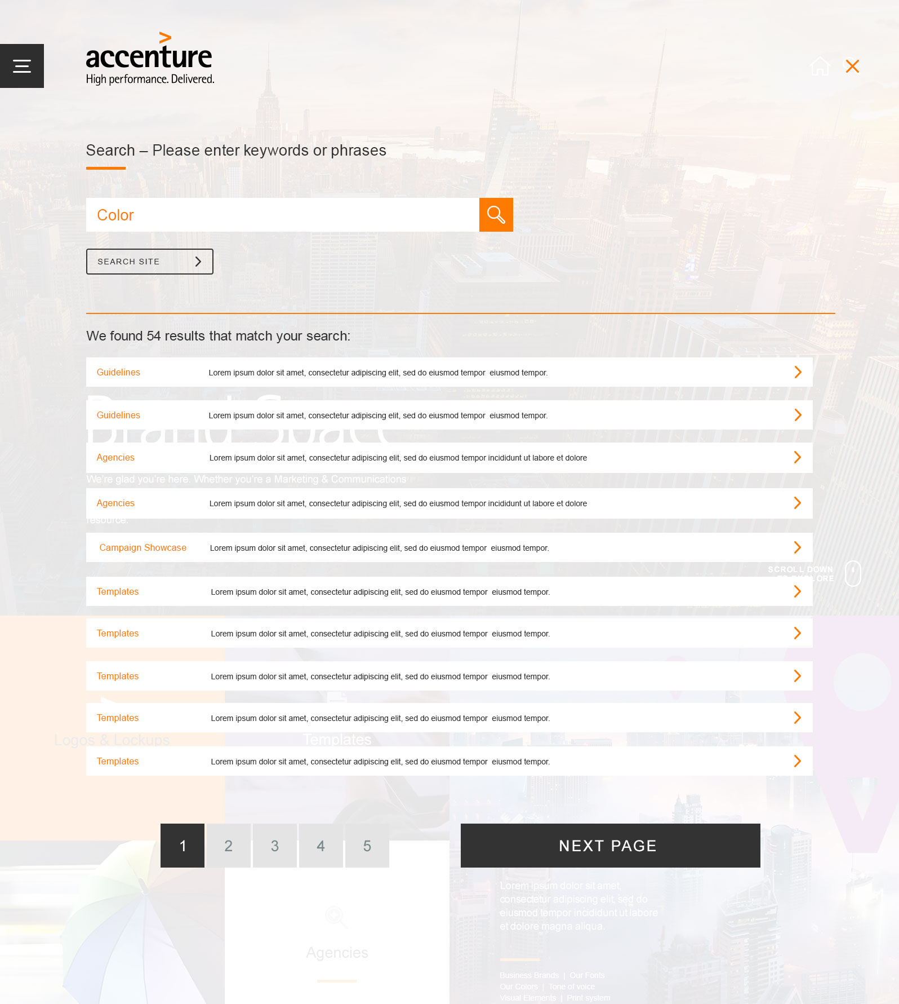

* After use input a keyword and click search button, search result will be shown with pagination, 10 items per page
* There is a sentence shown above the search result list - “We found xxx results that match your search:”
* Each result item includes area name it belongs to(areas are the same as options value in search area dropdown list), title of the page or item, and one right arrow
* If the item is a template, then the title displayed in the result should be size + template title
* Click each item’s title and right arrow icon will go to that page or item detail page, this page will be opened in a new window, so user is easy to go back to the search result page

## No Result Search

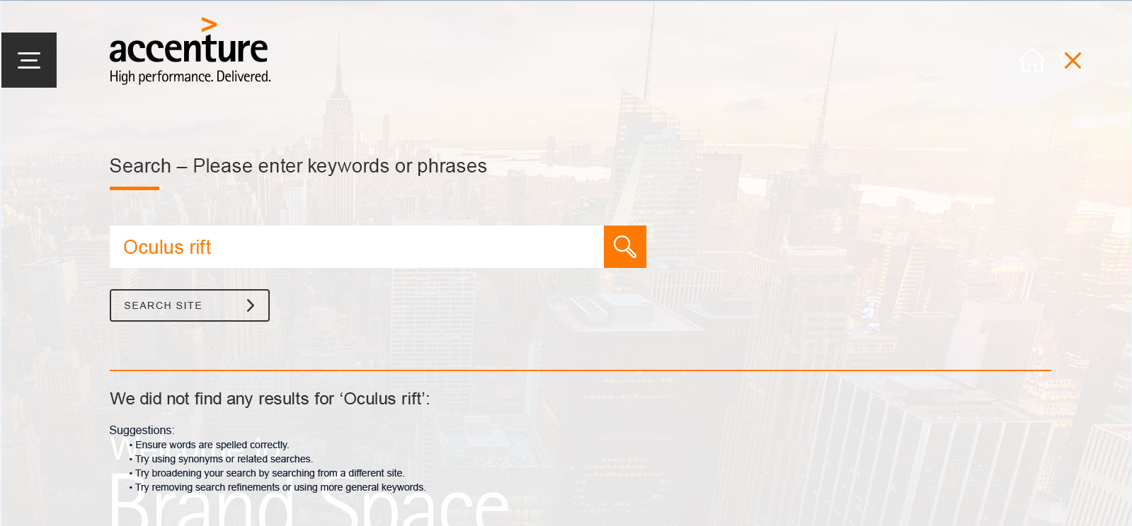

* When there is no result returned for a keyword, below message will be shown  
  We did not find any results for ‘Oculus rift’:  
  Suggestions:DELETE SUGGESTIONS
* • Ensure words are spelled correctly. • Try using synonyms or related searches. • Try broadening your search by searching from a different site. • Try removing search refinements or using more general keywords.